I. Introduction.
The 21-22 wrestling season was a tremendous success for the team, individual wrestlers, and our families. We were led by a strong senior class that pushed the team to an 8th place finish at States, with three landing on the podium, with one bringing home a state championship. The 22-23 season will give us the opportunity to return our remaining State qualifiers and be even more competitive in the district and regional tournaments across a strong lineup.
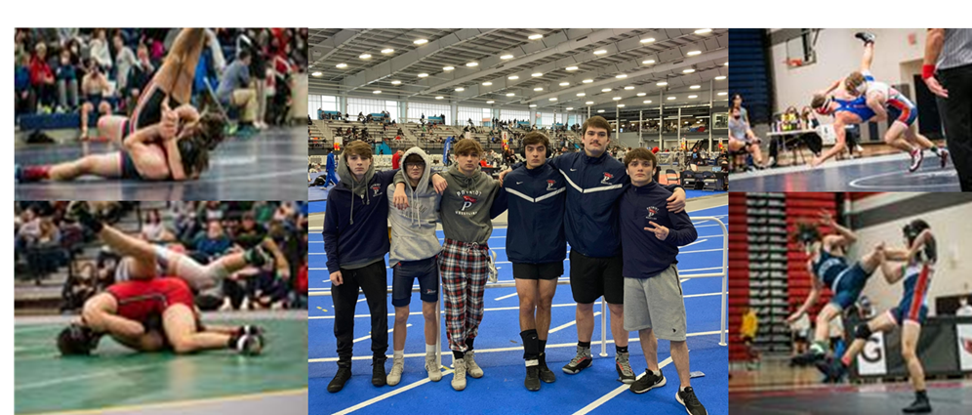

II. Coaching Philosophy.
We understand that our job as coaches is twofold: First, to develop each athlete to successfully compete in the world outside of athletics and excel as students. Second, we want to help each athlete in our program develop a love for and knowledge of the sport of wrestling, improve their fundamental skills, understand the rules and strategy.

III. Rules, Expectations, Attendance and Eligibility

All wrestlers will follow the rules of the team AT ALL TIMES. Many of these rules apply even during the off-season.
A. Use of Unauthorized Drugs, Alcohol, Steroids or Tobacco use will not be tolerated. Substance abuse issues will be handled as defined in the Patriot High School Code of Behavior.
B. You attend Patriot High School for an education. Any misbehavior during school will also be dealt with by your coaches. All discipline problems are defined in the Code of Behavior.
Patriot wrestlers WILL:
1. Make it on time to school and classes
2. Contribute to class discussion and any group work in a positive and constructive manner.

3. Serve as a positive role model to your fellow students and in your community.
C. Wrestlers will follow the rules governing the sport. You will be expected to show proper sportsmanship at all times: Respect your teammates, coaches, opponents and officials alike. This includes on social media. Online platforms are a great way to communicate information, establish an online profile to make yourself visible to recruiters if you intend to compete in college and to share personal and team achievements. You will not disparage other schools or your teammates, other Patriot HS students on your platforms.
D. The first official practice is November 7, 2022, (details to be published). Wrestling does not conclude until the state wrestling tournament on the third weekend in February.
E. Wrestlers are expected to ride the bus home from competition and will be dismissed from the school. Exceptions should be rare and require approval from Mr. Qualls ahead of time.
F. Eligibility Requirements. All students are allowed to participate in the sports program provided they meet the following requirements:
• Students are enrolled in 5 credit classes which can be used towards graduation.
• The student shall have passed, at the end of the semester, at least five credits with the minimum of 2 C’s and 3 D’s.
• Before participation in in-season or out of season activities can take place, the student shall have submitted to Patriot HS, Athletic Participation Parental Consent/ Physician’s Form completely filled in and properly signed by both parent/guardian and physician. The physical must be dated after May 1, 2022 and is good for the entire 2022-2023 school year. You may get a copy of this for from Patriot High School or the following website: www.patriotpioneers.org under the files section.
• Student must take the online Concussion Education training course prior to participating in in-season or out of season workouts: https://online_concussion.pwcs.edu/
• The student and parent must sign an Emergency Care Card and turn in to the Patriot High School activities office.
G. Communications. Team information will be disseminated on 3 platforms:
1. The school athletics website:
https://patriotpioneers.org/main/teamschedule/id/23606/seasonid/4715804
2. Team Twitter page:
https://twitter.com/Pat_wrestling
3. Family Facebook page (Patriot Pioneer Wrestling):
https://www.facebook.com/groups/407383733383698

